**TimeDemo(TimePicker DatePicker)**

**//MainActivity.java**

**package** com.example.timedemo;  
  
**import** androidx.appcompat.app.AppCompatActivity;  
  
**import** android.os.Bundle;  
**import** android.view.View;  
**import** android.widget.DatePicker;  
**import** android.widget.TimePicker;  
**import** android.widget.Toast;  
  
**public class** MainActivity **extends** AppCompatActivity {  
 TimePicker **tp**;  
 DatePicker **dp**;  
  
 @Override  
 **protected void** onCreate(Bundle savedInstanceState) {  
 **super**.onCreate(savedInstanceState);  
 setContentView(R.layout.***activity_main***);  
 **tp**=(TimePicker)findViewById(R.id.***timePicker***);  
 *// tp.setIs24HourView(true);* **dp**=(DatePicker)findViewById(R.id.***datePicker***);  
  
  
 }  
 **public void** onClick(View view) {  
  
 Toast.*makeText*(getBaseContext(),  
 **"Time Selected"**+**tp**.getHour()+**":"**+**tp**.getMinute(),  
 Toast.***LENGTH_SHORT***).show();  
 }  
  
 **public void** showDate(View view) {  
  
 Toast.*makeText*(getBaseContext(),  
 **"date selected"**+(**dp**.getMonth()+1)+  
 **"/"**+**dp**.getDayOfMonth()+  
 **"/"**+**dp**.getYear(),  
 Toast.***LENGTH_SHORT***).show();  
 }  
}

**//activity_main.xml**

*<?***xml version="1.0" encoding="utf-8"***?>*<**LinearLayout xmlns:android="http://schemas.android.com/apk/res/android"  
 xmlns:app="http://schemas.android.com/apk/res-auto"  
 xmlns:tools="http://schemas.android.com/tools"  
 android:layout_width="match_parent"  
 android:layout_height="match_parent"  
 android:orientation="vertical"  
 tools:context=".MainActivity"**>  
  
  
 <**TimePicker  
 android:id="@+id/timePicker"  
 android:layout_width="wrap_content"  
 android:layout_height="238dp"** />  
  
 <**Button  
 android:id="@+id/btnSet"  
 android:layout_width="70dp"  
 android:layout_height="31dp"  
 android:onClick="onClick"  
 tools:layout_editor_absoluteX="174dp"  
 tools:layout_editor_absoluteY="193dp"** />  
  
 <**DatePicker  
 android:id="@+id/datePicker"  
 android:layout_width="wrap_content"  
 android:layout_height="238dp"** />  
  
 <**Button  
 android:id="@+id/btndt"  
 android:layout_width="70dp"  
 android:layout_height="31dp"  
 android:onClick="showDate"  
 tools:layout_editor_absoluteX="174dp"  
 tools:layout_editor_absoluteY="193dp"** />  
</**LinearLayout**>

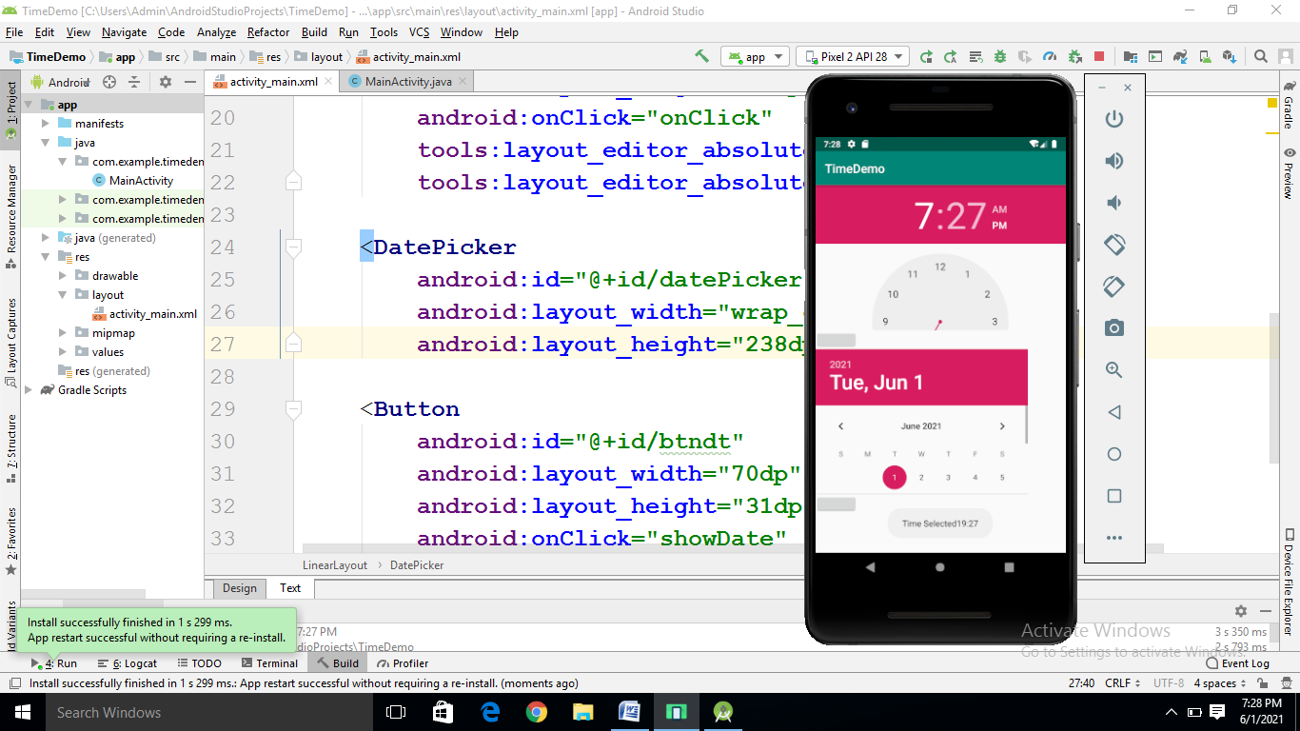

**BasicViews(Toggle Button)**

**//MainActivity.java**

**package** com.example.basicviews;  
  
**import** androidx.appcompat.app.AppCompatActivity;  
  
**import** android.os.Bundle;  
**import** android.view.View;  
**import** android.widget.Button;  
**import** android.widget.CheckBox;  
**import** android.widget.RadioButton;  
**import** android.widget.RadioGroup;  
**import** android.widget.Toast;  
**import** android.widget.ToggleButton;  
  
**public class** MainActivity **extends** AppCompatActivity {  
  
 @Override  
 **protected void** onCreate(Bundle savedInstanceState) {  
 **super**.onCreate(savedInstanceState);  
 setContentView(R.layout.***activity_main***);  
 Button btsave=(Button)findViewById(R.id.***button1***);  
 btsave.setOnClickListener(**new** View.OnClickListener() {  
 @Override  
 **public void** onClick(View v) {  
 Toast.*makeText*(getBaseContext(),**"you clicked save button"**,Toast.***LENGTH_SHORT***).show();  
  
 }  
 });  
 Button btopen=(Button)findViewById(R.id.***button2***);  
 btopen.setOnClickListener(**new** View.OnClickListener() {  
 @Override  
 **public void** onClick(View v) {  
 Toast.*makeText*(getBaseContext(),**"you clicked open button"**,Toast.***LENGTH_SHORT***).show();  
 }  
 });  
 **final** CheckBox chk=(CheckBox)findViewById(R.id.***checkBox***);  
 chk.setOnClickListener(**new** View.OnClickListener() {  
 @Override  
 **public void** onClick(View v) {  
 **if** (((CheckBox)v).isChecked())  
  
 Toast.*makeText*(getBaseContext(),**"you checked check box1 button"**,Toast.***LENGTH_SHORT***).show();  
 **else** Toast.*makeText*(getBaseContext(),**"you unchecked check box1 button"**,Toast.***LENGTH_SHORT***).show();  
 }  
 });  
 RadioGroup rgb=(RadioGroup)findViewById(R.id.***rdgrp1***);  
 rgb.setOnCheckedChangeListener(**new** RadioGroup.OnCheckedChangeListener() {  
 @Override  
 **public void** onCheckedChanged(RadioGroup group, **int** checkedId) {  
 RadioButton rb1= (RadioButton)findViewById(R.id.***rd1***);  
 **if** (rb1.isChecked())  
 {  
 Toast.*makeText*(getBaseContext(),**"you checked option1"**,Toast.***LENGTH_SHORT***).show();  
 }  
 **else** {  
 Toast.*makeText*(getBaseContext(),**"you checked option2"**,Toast.***LENGTH_SHORT***).show();  
 }  
 }  
 });  
 ToggleButton tb=(ToggleButton)findViewById(R.id.***toggle1***);  
 tb.setOnClickListener(**new** View.OnClickListener() {  
 @Override  
 **public void** onClick(View v) {  
 **if**(((ToggleButton)v).isChecked())  
 {Toast.*makeText*(getBaseContext(),**"toggle button is on"**,Toast.***LENGTH_SHORT***).show();}  
 **else** {Toast.*makeText*(getBaseContext(),**"toggle button is off"**,Toast.***LENGTH_SHORT***).show();} }  
 });  
 }  
}

**//activity_main.xml**

*<?***xml version="1.0" encoding="utf-8"***?>*<**LinearLayout xmlns:android="http://schemas.android.com/apk/res/android"  
 xmlns:app="http://schemas.android.com/apk/res-auto"  
 xmlns:tools="http://schemas.android.com/tools"  
 android:layout_width="fill_parent"  
 android:layout_height="fill_parent"  
 android:orientation="vertical"  
 tools:context=".MainActivity"**>  
  
 <**Button  
 android:id="@+id/button1"  
 android:layout_width="fill_parent"  
 android:layout_height="wrap_content"  
  
 android:text="save"** />  
  
 <**Button  
 android:id="@+id/button2"  
 android:layout_width="fill_parent"  
 android:layout_height="wrap_content"  
  
 android:text="open"** />  
  
 <**ImageButton  
 android:id="@+id/btnimg"  
 android:layout_width="fill_parent"  
 android:layout_height="wrap_content"  
 android:src="@mipmap/pic3"** />  
 <**TextView  
 android:id="@+id/text1"  
 android:layout_width="fill_parent"  
 android:layout_height="wrap_content"**/>  
  
  
 <**EditText  
 android:id="@+id/editText"  
 android:layout_width="wrap_content"  
 android:layout_height="wrap_content"  
 android:text="Name"** />  
  
 <**CheckBox  
 android:id="@+id/checkBox"  
 android:layout_width="fill_parent"  
 android:layout_height="wrap_content"  
 android:text="CheckBox"** />  
  
 <**CheckBox  
 android:id="@+id/checkBox2" style="?android:attr/starStyle"  
 android:layout_width="wrap_content"  
 android:layout_height="wrap_content"  
 android:text="CheckBox"** />  
  
 <**RadioGroup  
 android:id="@+id/rdgrp1"  
 android:layout_width="fill_parent"  
 android:layout_height="wrap_content"  
 android:orientation="vertical"** >  
  
 <**RadioButton  
 android:id="@+id/rd1"  
 android:layout_width="fill_parent"  
 android:layout_height="wrap_content"  
 android:text="option1"**/>  
 <**RadioButton  
 android:id="@+id/rd2"  
 android:layout_width="fill_parent"  
 android:layout_height="wrap_content"  
 android:text="option2"**/>  
 </**RadioGroup**>  
 <**ToggleButton  
 android:id="@+id/toggle1"  
 android:layout_width="wrap_content"  
 android:layout_height="wrap_content"** />  
</**LinearLayout**>

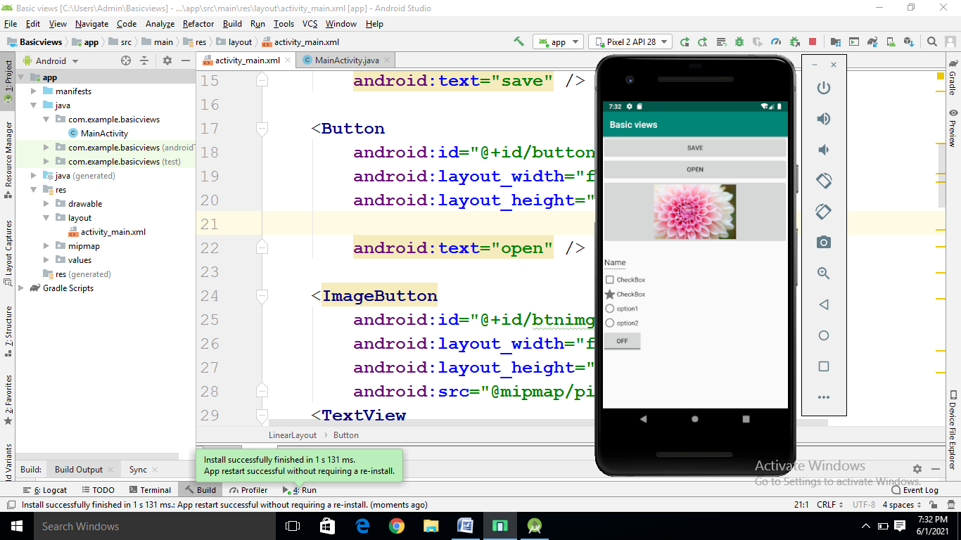

**Qu) Program to show lifecycle of activity**

**MainActivity.java**

**package** com.example.tybca;  
  
**import** androidx.appcompat.app.AppCompatActivity;  
**import** android.os.Bundle;  
**import** android.util.Log;  
  
**import** android.os.Bundle;  
**import** android.widget.Toast;  
  
**public class** MainActivity **extends** AppCompatActivity {  
String **tag**=**"Events"**;  
  
 @Override  
 **protected void** onCreate(Bundle savedInstanceState) {  
 **super**.onCreate(savedInstanceState);  
 setContentView(R.layout.***activity_main***);  
 Log.*d*(**tag**,**"in on create event"**);  
 *//Displaying Toast with Hello Javatpoint message* Toast.*makeText*(getApplicationContext(),**"Hello TYBCA Student"**,Toast.***LENGTH_SHORT***).show();  
  
  
 }  
  
 @Override  
 **public void** onStart() {  
 **super**.onStart();  
 Log.*d*(**tag**,**"in on start event"**);  
 }  
  
 @Override  
 **public void** onStop() {  
 **super**.onStop();  
 Log.*d*(**tag**,**"in on stop event"**);  
 }  
  
  
  
 @Override  
 **protected void** onResume() {  
 **super**.onResume();  
 Log.*d*(**tag**,**"in on resume event"**);  
 }  
  
 @Override  
 **public void** onPause() {  
 **super**.onPause();  
 Log.*d*(**tag**,**"in on pause event"**);  
  
 }  
  
  
 @Override  
 **protected void** onDestroy() {  
 **super**.onDestroy();  
 Log.*d*(**tag**,**"in on Destroy event"**);  
 }  
}

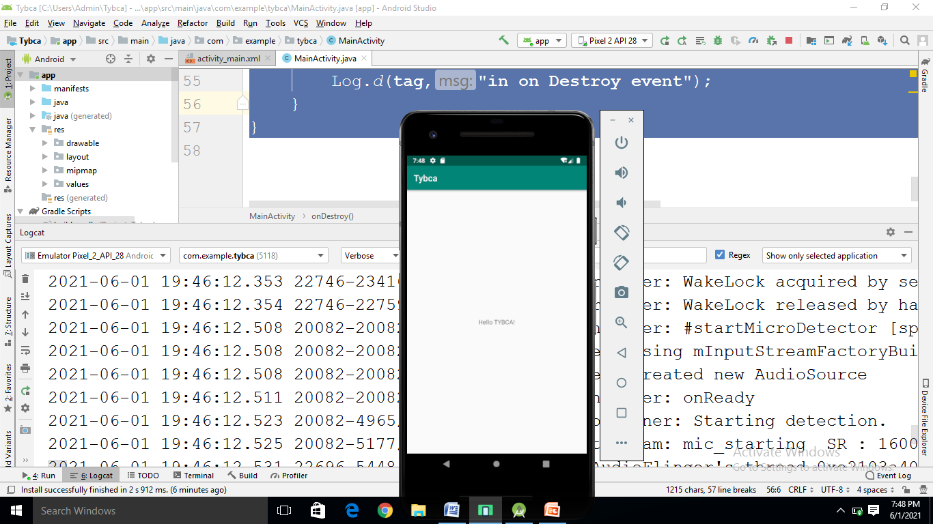

**// (Scroll view)**

**//Activity_Main.java**

**package** com.example.slip22_1;  
  
**import** androidx.appcompat.app.AppCompatActivity;  
  
**import** android.os.Bundle;  
  
**public class** MainActivity **extends** AppCompatActivity {  
  
 @Override  
 **protected void** onCreate(Bundle savedInstanceState) {  
 **super**.onCreate(savedInstanceState);  
 setContentView(R.layout.***activity_main***);  
 }  
}

**//activity_main.xml**

*<?***xml version="1.0" encoding="utf-8"***?>*<**androidx.constraintlayout.widget.ConstraintLayout xmlns:android="http://schemas.android.com/apk/res/android"  
 xmlns:app="http://schemas.android.com/apk/res-auto"  
 xmlns:tools="http://schemas.android.com/tools"  
 android:layout_width="match_parent"  
 android:layout_height="match_parent"  
 tools:context=".MainActivity"**>  
  
 <**ScrollView  
 android:layout_width="match_parent"  
 android:layout_height="match_parent"**>  
  
 <**LinearLayout  
 android:layout_width="match_parent"  
 android:layout_height="wrap_content"  
 android:orientation="vertical"**>  
 <**Button  
 android:layout_width="wrap_content"  
 android:layout_height="wrap_content"  
 android:layout_gravity="center"  
 android:text="Button 1"** />  
 <**Button  
 android:layout_width="wrap_content"  
 android:layout_height="wrap_content"  
 android:layout_gravity="center"  
 android:text="Button 2"** />  
 <**Button  
 android:layout_width="wrap_content"  
 android:layout_height="wrap_content"  
 android:layout_gravity="center"  
 android:text="Button 3"** />  
 <**Button  
 android:layout_width="wrap_content"  
 android:layout_height="wrap_content"  
 android:layout_gravity="center"  
 android:text="Button 4"** />  
 <**Button  
 android:layout_width="wrap_content"  
 android:layout_height="wrap_content"  
 android:layout_gravity="center"  
 android:text="Button 5"** />  
 <**Button  
 android:layout_width="wrap_content"  
 android:layout_height="wrap_content"  
 android:layout_gravity="center"  
 android:text="Button 6"** />  
 <**Button  
 android:layout_width="wrap_content"  
 android:layout_height="wrap_content"  
 android:layout_gravity="center"  
 android:text="Button 7"** />  
  
 <**Button  
 android:layout_width="wrap_content"  
 android:layout_height="wrap_content"  
 android:layout_gravity="center"  
 android:text="Button 10"** />  
  
 <**Button  
 android:layout_width="wrap_content"  
 android:layout_height="wrap_content"  
 android:layout_gravity="center"  
 android:text="Button 8"** />  
 <**Button  
 android:layout_width="wrap_content"  
 android:layout_height="wrap_content"  
 android:layout_gravity="center"  
 android:text="Button 9"** />  
  
 <**Button  
 android:layout_width="wrap_content"  
 android:layout_height="wrap_content"  
 android:layout_gravity="center"  
 android:text="Button 11"** />  
 <**Button  
 android:layout_width="wrap_content"  
 android:layout_height="wrap_content"  
 android:layout_gravity="center"  
 android:text="Button 12"** />  
 <**Button  
 android:layout_width="wrap_content"  
 android:layout_height="wrap_content"  
 android:layout_gravity="center"  
 android:text="Button 13"** />  
 <**Button  
 android:layout_width="wrap_content"  
 android:layout_height="wrap_content"  
 android:layout_gravity="center"  
 android:text="Button 14"** />  
 <**Button  
 android:layout_width="wrap_content"  
 android:layout_height="wrap_content"  
 android:layout_gravity="center"  
 android:text="Button 15"** />  
 <**Button  
 android:layout_width="fill_parent"  
 android:layout_height="wrap_content"  
 android:text="Button 16"** />  
 <**Button  
 android:layout_width="wrap_content"  
 android:layout_height="wrap_content"  
 android:layout_gravity="center"  
 android:text="Button 17"** />  
 <**Button  
 android:layout_width="wrap_content"  
 android:layout_height="wrap_content"  
 android:layout_gravity="center"  
 android:text="Button 18"** />  
  
 <**Button  
 android:layout_width="wrap_content"  
 android:layout_height="wrap_content"  
 android:layout_gravity="center"  
 android:text="Button 19"** />  
 <**Button  
 android:layout_width="wrap_content"  
 android:layout_height="wrap_content"  
 android:layout_gravity="center"  
 android:text="Button 20"** />  
  
 </**LinearLayout**>  
 </**ScrollView**>  
  
  
</**androidx.constraintlayout.widget.ConstraintLayout**>

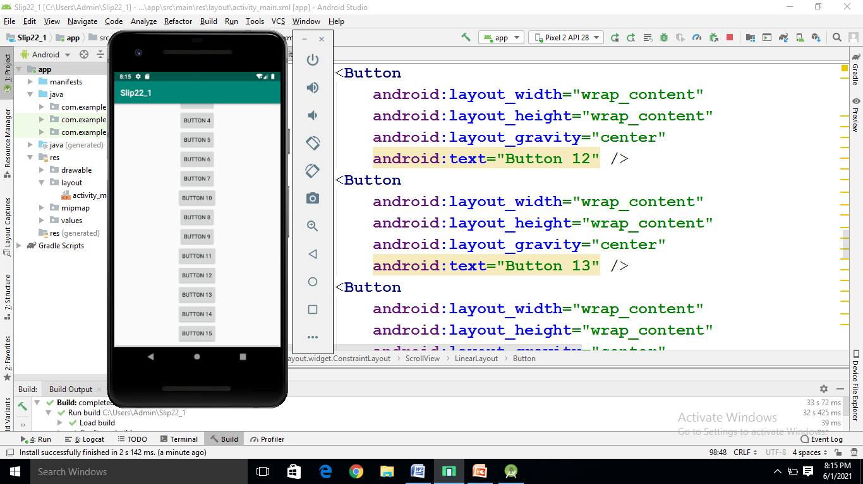

**Create an application that will change color of screen and change the font size of text view using xml**

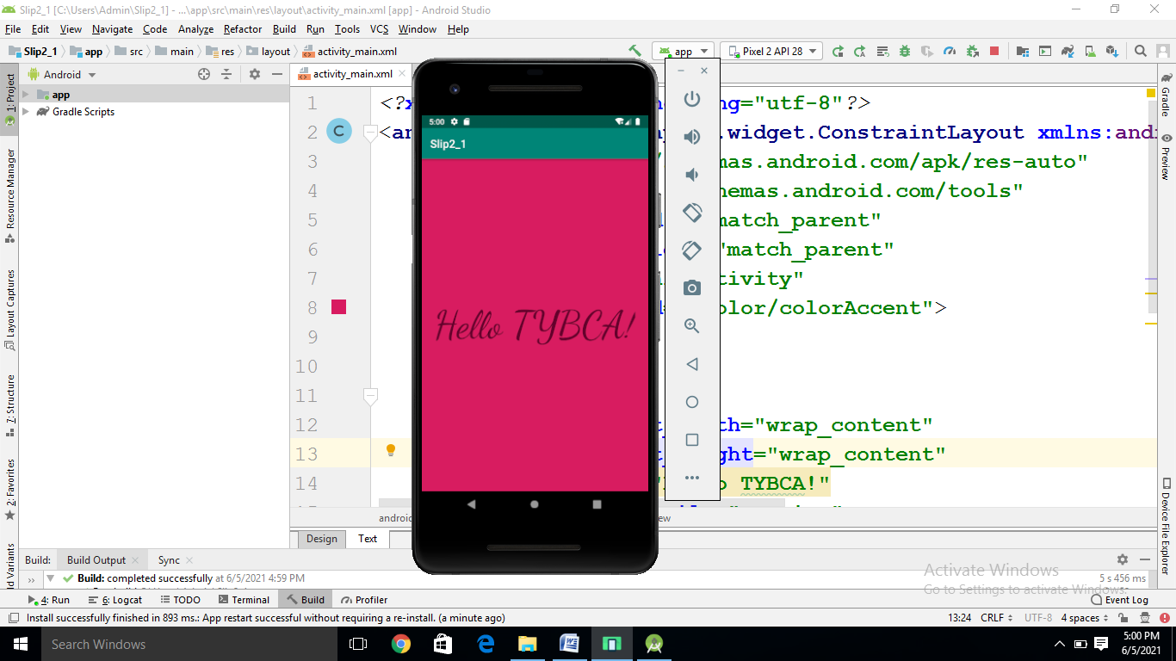

*<?***xml version="1.0" encoding="utf-8"***?>*<**androidx.constraintlayout.widget.ConstraintLayout xmlns:android="http://schemas.android.com/apk/res/android"  
 xmlns:app="http://schemas.android.com/apk/res-auto"  
 xmlns:tools="http://schemas.android.com/tools"  
 android:layout_width="match_parent"  
 android:layout_height="match_parent"  
 tools:context=".MainActivity"  
 android:background="@color/colorAccent"**>  
  
  
 <**TextView  
 android:layout_width="wrap_content"  
 android:layout_height="wrap_content"  
 android:text="Hello TYBCA!"  
 android:fontFamily="cursive"  
 android:textSize="70dp"  
 app:layout_constraintBottom_toBottomOf="parent"  
 app:layout_constraintLeft_toLeftOf="parent"  
 app:layout_constraintRight_toRightOf="parent"  
 app:layout_constraintTop_toTopOf="parent"** />  
  
</**androidx.constraintlayout.widget.ConstraintLayout**>

Slip1_1

Create Hello_world application that will display Hello world in middle of the screen in blue color with white background with border

//activity_main.xml

*<?***xml version="1.0" encoding="utf-8"***?>*<**RelativeLayout xmlns:android="http://schemas.android.com/apk/res/android"  
 xmlns:app="http://schemas.android.com/apk/res-auto"  
 xmlns:tools="http://schemas.android.com/tools"  
 android:layout_width="match_parent"  
 android:layout_height="match_parent"  
 android:background="#000000"  
 android:padding="10dp"  
  
 tools:context=".MainActivity"**>  
 <**LinearLayout  
 android:layout_width="match_parent"  
 android:layout_height="match_parent"  
 android:orientation="horizontal"  
 android:background="@drawable/border"**>  
  
 <**TextView  
 android:layout_width="fill_parent"  
 android:layout_height="fill_parent"  
 android:gravity="center_vertical|center_horizontal"  
 android:text="Hello World!"  
 android:background="#A00000FF"  
  
  
 android:textColor="#ffffff"  
 android:textSize="40sp"** />  
 </**LinearLayout**>  
  
</**RelativeLayout**>

**//border.xml**

*<?***xml version="1.0" encoding="utf-8"***?>*<**shape xmlns:android="http://schemas.android.com/apk/res/android"  
 android:shape="rectangle"**>  
 <**stroke  
 android:width="20dp"  
 android:color="#ffffff"**></**stroke**>  
  
</**shape**>

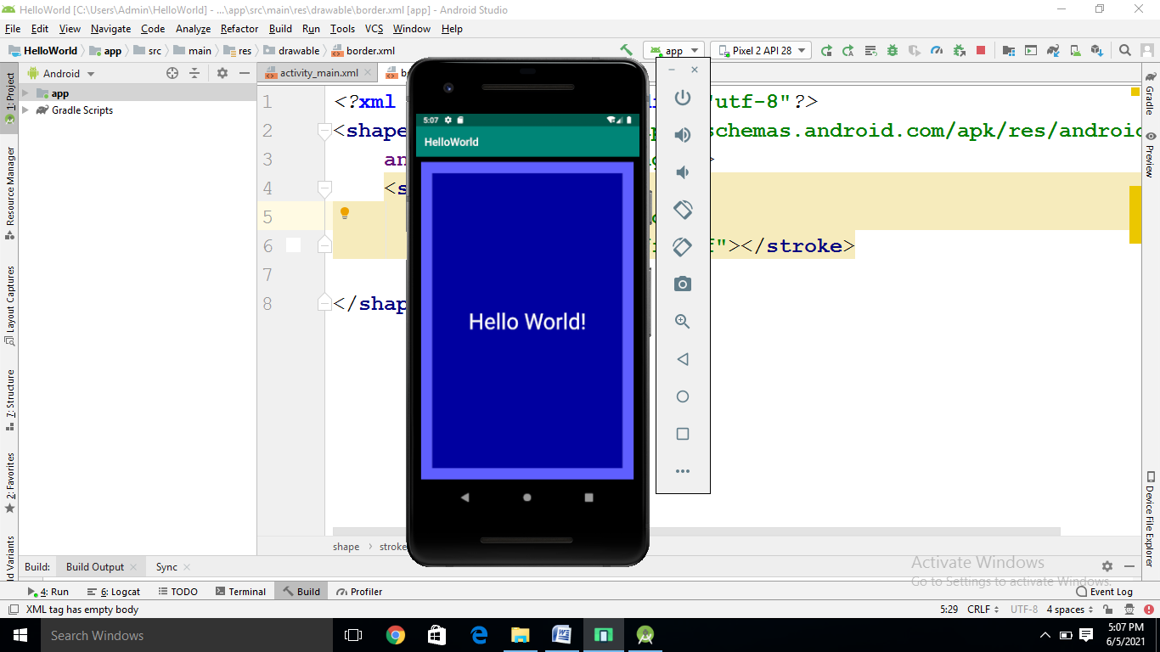

//Intent Demo

//MainActivity.java

**package** com.example.intentdemo;  
  
**import** androidx.appcompat.app.AppCompatActivity;  
  
**import** android.content.Intent;  
**import** android.net.Uri;  
**import** android.os.Bundle;  
**import** android.view.View;  
**import** android.widget.Button;  
  
**public class** MainActivity **extends** AppCompatActivity {  
Button **b1**;  
  
 @Override  
 **protected void** onCreate(Bundle savedInstanceState) {  
 **super**.onCreate(savedInstanceState);  
 setContentView(R.layout.***activity_main***);  
 **b1**=(Button)findViewById(R.id.***button1***);  
  
  
 **b1**.setOnClickListener(**new** View.OnClickListener() {  
 @Override  
 **public void** onClick(View v) {  
 Intent i=**new** Intent(Intent.***ACTION_DIAL***, Uri.*parse*(**"tel:+9860539978"**));  
  
 startActivity(i);  
  
 }  
 });  
 }  
  
 @Override  
 **public void** onBackPressed() {  
 **super**.onBackPressed();  
 Intent i=**new** Intent(**this**,SecondActivity.**class**);  
 startActivity(i);  
 }  
}

//main_activity.xml

*<?***xml version="1.0" encoding="utf-8"***?>*<**LinearLayout xmlns:android="http://schemas.android.com/apk/res/android"  
 xmlns:app="http://schemas.android.com/apk/res-auto"  
 xmlns:tools="http://schemas.android.com/tools"  
 android:layout_width="match_parent"  
 android:layout_height="match_parent"  
 tools:context=".MainActivity"**>  
  
 <**TextView  
 android:layout_width="wrap_content"  
 android:layout_height="wrap_content"  
 android:text="Hello World!"  
 app:layout_constraintBottom_toBottomOf="parent"  
 app:layout_constraintLeft_toLeftOf="parent"  
 app:layout_constraintRight_toRightOf="parent"  
 app:layout_constraintTop_toTopOf="parent"** />  
 <**Button  
 android:layout_width="match_parent"  
 android:layout_height="wrap_content"  
 android:id="@+id/button1"  
 android:text="Contact"** />  
  
</**LinearLayout**>

//SecondActivity.java

**package** com.example.intentdemo;  
  
**import** androidx.appcompat.app.AppCompatActivity;  
  
**import** android.os.Bundle;  
  
**public class** SecondActivity **extends** AppCompatActivity {  
  
 @Override  
 **protected void** onCreate(Bundle savedInstanceState) {  
 **super**.onCreate(savedInstanceState);  
 setContentView(R.layout.***activity_second***);  
 }  
}

//activity_second.xml

*<?***xml version="1.0" encoding="utf-8"***?>*<**LinearLayout xmlns:android="http://schemas.android.com/apk/res/android"  
 xmlns:app="http://schemas.android.com/apk/res-auto"  
 xmlns:tools="http://schemas.android.com/tools"  
 android:layout_width="match_parent"  
 android:layout_height="match_parent"  
 android:orientation="vertical"  
 tools:context=".SecondActivity"**>  
 <**TextView  
 android:layout_width="wrap_content"  
 android:layout_height="wrap_content"  
 android:id="@+id/text1"  
 android:text="Second Activity"**>  
  
 </**TextView**>  
 </**LinearLayout**>

//ListviewDemo

**package** com.example.listview;  
  
**import** androidx.appcompat.app.AppCompatActivity;  
  
**import** android.app.ListActivity;  
**import** android.os.Bundle;  
**import** android.view.View;  
**import** android.widget.AdapterView;  
**import** android.widget.ArrayAdapter;  
**import** android.widget.ListView;  
**import** android.widget.TextView;  
**import** android.widget.Toast;  
  
**public class** MainActivity **extends** ListActivity  
{  
 String **countryList**[] = {**"India"**, **"China"**, **"australia"**, **"Portugle"**, **"America"**, **"NewZealand"**};  
  
@Override **public void** onCreate(Bundle savedInstanceState) {  
 **super**.onCreate(savedInstanceState);  
 ListView lstview=getListView();  
 *// ListView lstview= (ListView)findViewById(R.id.simpleListView);* lstview.setChoiceMode(ListView.***CHOICE_MODE_MULTIPLE***);  
 lstview.setTextFilterEnabled(**true**);  
 setListAdapter(**new** ArrayAdapter<String>(**this**,android.R.layout.***simple_list_item_1***,**countryList**));  
  
 }  
  
 @Override  
 **public void** onListItemClick(ListView l, View v, **int** position, **long** id) {  
 *//super.onListItemClick(l, v, position, id);* Toast.*makeText*(**this**,**"you select"**+**countryList**[position],Toast.***LENGTH_SHORT***).show();  
 }  
}

//activity_main.xml

*<?***xml version="1.0" encoding="utf-8"***?>*<**LinearLayout  
 xmlns:android="http://schemas.android.com/apk/res/android"  
 android:layout_width="match_parent"  
 android:layout_height="match_parent"  
 android:orientation="vertical"**>  
  
 <**ListView  
 android:id="@+id/simpleListView"  
 android:layout_width="fill_parent"  
 android:layout_height="wrap_content"  
 android:divider="@color/material_blue_grey_800"  
 android:dividerHeight="1dp"** />  
</**LinearLayout**>

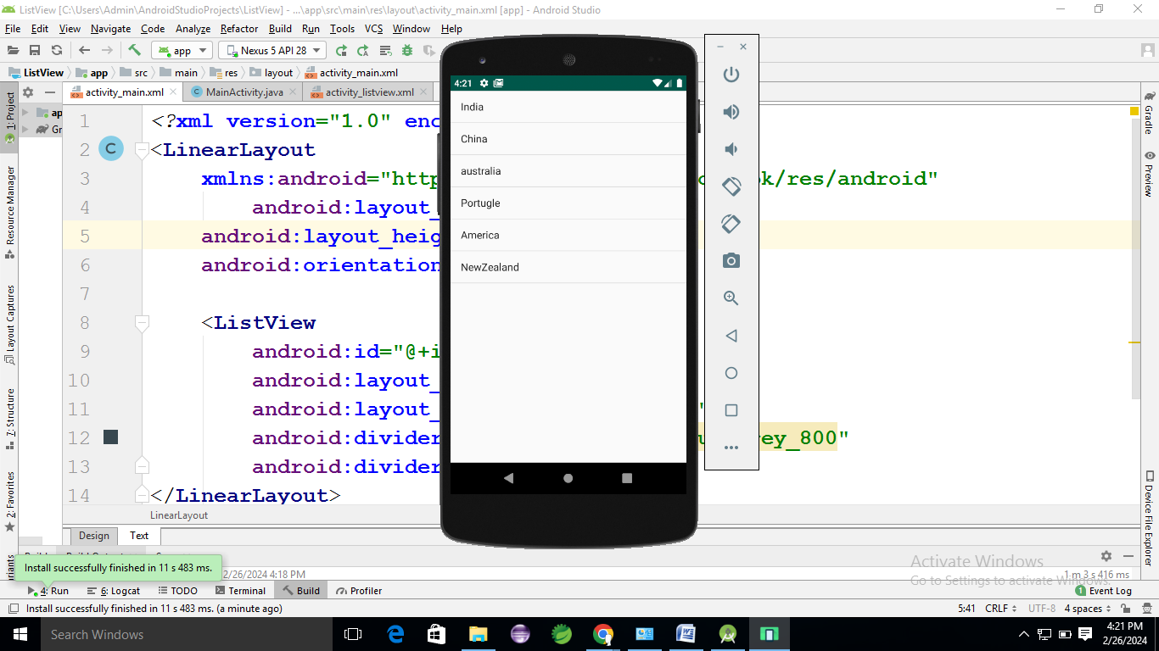

//Slip12_1

//MainActivity.java

**package** com.example.newslip12_1;  
  
**import** androidx.appcompat.app.AppCompatActivity;  
  
**import** android.os.Bundle;  
**import** android.widget.EditText;  
**import** android.view.View;  
**import** android.widget.Button;  
**import** android.content.Intent;  
**public class** MainActivity **extends** AppCompatActivity {  
 @Override  
 **protected void** onCreate(Bundle savedInstanceState) {  
 **super**.onCreate(savedInstanceState);  
 setContentView(R.layout.***activity_main***);  
 **final** EditText editText = findViewById(R.id.***mname***);  
 Button button = findViewById(R.id.***button***);  
 button.setOnClickListener(**new** View.OnClickListener() {  
 @Override  
 **public void** onClick(View v) {  
  
 String msg=editText.getText().toString().trim();  
 Bundle bundle = **new** Bundle();  
 bundle.putString(**"value1"**,msg);  
 Intent intent = **new** Intent(MainActivity.**this**, SecondActivity.**class**);  
 intent.putExtras(bundle);  
 startActivity(intent);  
  
  
 }  
 });  
 }  
}

//activit_main.xml

*<?***xml version="1.0" encoding="utf-8"***?>*<**LinearLayout xmlns:android="http://schemas.android.com/apk/res/android"  
 xmlns:app="http://schemas.android.com/apk/res-auto"  
 xmlns:tools="http://schemas.android.com/tools"  
 android:layout_width="match_parent"  
 android:layout_height="match_parent"  
 android:orientation="vertical"  
 tools:context=".MainActivity"**>  
  
 <**EditText  
 android:id = "@+id/mname"  
 android:layout_width = "match_parent"  
 android:layout_height = "wrap_content"  
 android:layout_gravity = "center"  
 android:hint = "Enter message"  
 android:inputType = "text"** />  
 <**Button  
 android:id = "@+id/button"  
 android:layout_width = "wrap_content"  
 android:layout_height = "wrap_content"  
 android:layout_gravity = "center"  
 android:layout_marginTop = "16dp"  
 android:text = "Next"** />  
</**LinearLayout**>

//SecondActivity.java

**package** com.example.newslip12_1;  
  
**import** androidx.appcompat.app.AppCompatActivity;  
  
**import** android.os.Bundle;  
**import** android.content.Intent;  
**import** android.widget.TextView;  
**public class** SecondActivity **extends** AppCompatActivity {  
  
 @Override  
 **protected void** onCreate(Bundle savedInstanceState) {  
 **super**.onCreate(savedInstanceState);  
 setContentView(R.layout.***activity_second***);  
 Bundle bundle = getIntent().getExtras();  
 **if** (bundle != **null**) {  
 String value = bundle.getString(**"value1"**);  
 TextView textView = findViewById(R.id.***text_view***);  
 textView.setText(value);  
  
 }  
 }  
}

//activity_second.xml

*<?***xml version="1.0" encoding="utf-8"***?>*<**LinearLayout xmlns:android="http://schemas.android.com/apk/res/android"  
 xmlns:app="http://schemas.android.com/apk/res-auto"  
 xmlns:tools="http://schemas.android.com/tools"  
 android:layout_width="match_parent"  
 android:layout_height="match_parent"  
 android:orientation="vertical"  
 tools:context=".SecondActivity"**>  
 <**TextView  
 android:id = "@+id/text_view"  
 android:layout_width = "match_parent"  
 android:layout_height = "wrap_content"  
 android:layout_gravity = "center"** />  
</**LinearLayout**>

